Noise Margin

What is NM?

What margin is available for noise. Means up to what extent noise is allowed so that we can properly extract logic 1 or 0.

Nosie margin explains up to what level noise cannot interfere when IC transmits high or low signal.

In theory, we receive only two voltages – one for high commonly referred as 1 and one for low commonly referred as 0

However, in practice, we receive more than two voltages.

In IC, we receive a range of voltages.

Based on a range, we identify 1 or 0

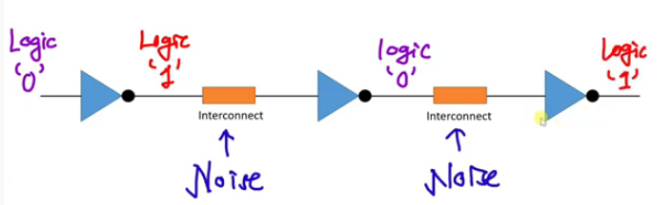

Voltage Transfer Characteristics

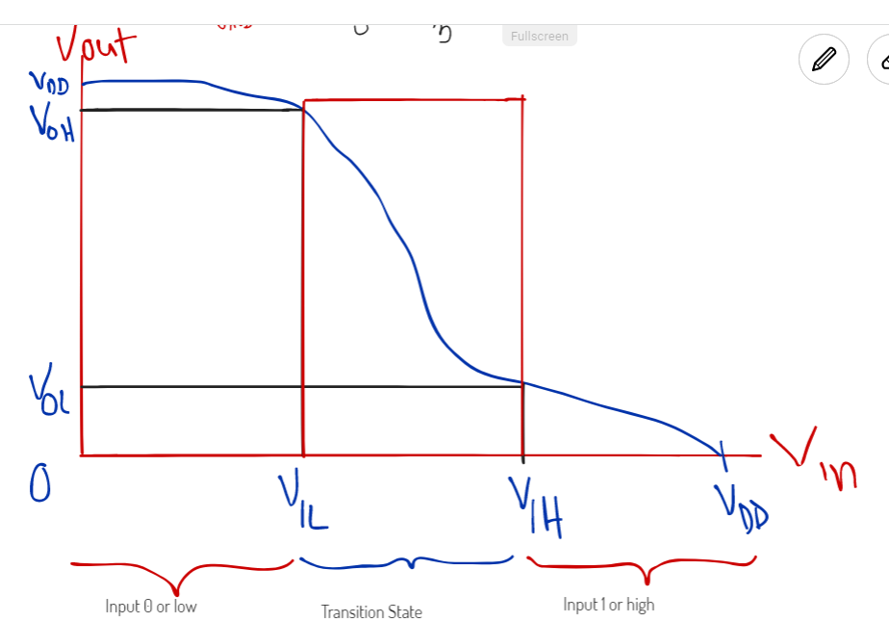

Voltage output vs Voltage Input:

